If you are having upper or lower respiratory symptoms on your day of visit, please text 828-606-1955 to schedule a video medical visit.
Location of Pain (if applicable) 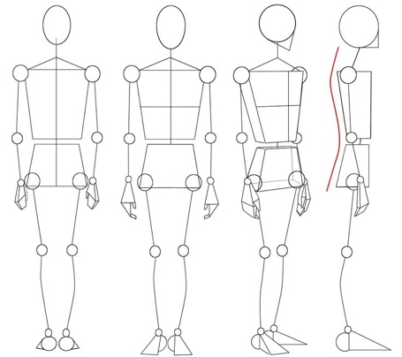

Name: _______________________
Cell number: ____________________
Email:__________________________
Home Street address:______________
_______________________________
Today’s Date: _________________
Date of Birth: _________________
Whom may I thank for referring you? ________________
What is the main reason for your visit?

When did you first become aware of the main problem?

What Medications do you take? Doses?

Past Medical history:

    - Heart failure
    - Atrial fibrillation or other irregular heart rhythm
    - Heart racing/skipping beats/palpitations
    - History of heart attack
    - Heart catheterization. When? If stents, what arteries?
    - Heart Bypass When? What arteries?
    - Vascular disease
    - Heart Valve disease
    - Sleep apnea? Compliant with device?
    - Congenital heart disease
        - Stroke/ TIA
    - Chest pain/tightness/pressure/discomfort
        - High blood pressure
        - High lipids/cholesterol
        - Severe/unusual Headaches
        - Fainting, nearly fainting or dizziness
        - Loss of/altered sense of smell or taste
        - Tooth/gum infections or extractions
        - COPD or lung disease
    - Gall stones
        - Change in Stools
    - Blood clots or varicose veins
    - Kidney disease
        - Problems with sexual function.
    - Hepatitis
    - HIV
    - Cancer, what kind? _______________ Last treatment date?
    - Diabetes
    - Exposure to noxious fumes

Current complaints:

    - Weight gain or loss without trying
    - Depression/ other mental health diagnoses
    - Palpitations
    - Post COVID syndrome
    - Heart Burn
    - Frequent night time urination
    - Vericose veins
    - Pain in calves when walking
    - Shortness of breath with exertion
    - Resting shortness of breath
    - Chest pain
    - Dark tarry stools
    - Panic or high level of stress
    - Loss of interest in activities you used to enjoy
    - Abdominal pain
    - Heartburn
    - Gait or balance problems
    - Ankle swelling

Hospitalizations and surgeries: _____________________________________________
___________________________________________________________________________

Allergies (or sensitivity) and the symptom(s):

Parents, Aunts, Uncles and Grandparents diseases (prior to age 65 years old):
__Heart disease /stroke
__High cholesterol
__heart rhythm problem
__Varicose veins
__Heart surgery
__Sudden death unexplained
__Cancer
__Diabetes
__Asthma / allergies
__Substance use disorder
__Sleep problems
__other disease _____________
Age and cause, if your Mother has passed on:
Age and cause, if your Father has passed on:

HEALTH MAINTENANCE:

Work outs: how often, how long?
Whom do you live with?
How often do you eat out?
Who does most of the cooking?
Would you prefer to cook for yourself, or have someone else cook for you?
Have you tried My Fitness Pal app or other food diary?
How many glasses of water do you drink per day?
TV /Computer hours per day:
Smoking/vape (any type) chew (ever)? # Years:___#packs/day:___ Year since quit:
Alcohol intake: how many drinks per week?
Sugary or artificially sweetened drinks # per day?
Caffeinated drinks per day?
Please note any of the following causing stress:
__Childhood/past stressors __Family relationships __Health __Work __School __Finances
What is your average home BP?
What is the first thing you would change to prevent illness?
Heart Results:
Cardiac Stress Test Year_____. Result: _____ Echocardiogram Year______Result______
Heart Monitor Year ______- Result_______ Heart Catheterization Year____ Stented arteries:_______
Pacemaker?____Year _____ Heart Valve replacement/repair?________
If available, please provide recent results from blood draws (past 6 months):

Please email recent lab results, EKG, CT scan reportt, X-ray report, cardiac stress test report, ultrasound report, echocardiogram result, heart monitor report.

Name(s) of people we can talk to about you care:_____________________________________________________________
Relationship to you:_________________________________________________

Thank you for entrusting us with your care.

